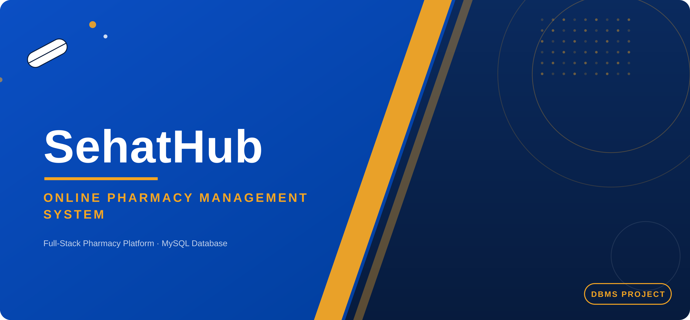
PROJECT DOCUMENTATION
SehatHub Project Report
Database Management Systems · 4th Semester · Full-Stack Web Application
COURSE  Database Management Systems (DBMS), 4th Semester |  | PROJECT TYPE  Semester Project, Full-Stack Web Application

SUBMITTED BY
Syed Obaid Ali (Roll No: 9321)
Sikander (Roll No: 9315)
Sadaqat Hussain (Roll No: 2979)

SehatHub Development Team • DBMS Semester Project

Table of Contents

1. Introduction 3
2. Project Objectives 3
3. System Architecture & User Roles 3
4. Database Design 4
5. Key Features 7
6. Security Implementation 11
7. Technology Stack 11
8. Sample Database Queries 12
9. Conclusion & Future Scope 14

1. Introduction

◆ 1.1 Problem Statement
Local pharmacies in Pakistan largely depend on manual, paper-based systems to manage inventory, sales, and prescriptions. This creates recurring problems: customers must physically visit multiple stores to find specific medicines, paper prescriptions are easy to lose or misread, orders cannot be tracked once placed, and stock-outs often go unnoticed until a customer is already at the counter.

◆ 1.2 Proposed Solution
SehatHub is a full-stack online pharmacy platform, built as a DBMS semester project for real-world online medicine ordering. It digitizes the complete pharmacy workflow, including browsing medicines, uploading prescriptions, placing orders, and tracking deliveries, on top of a normalized MySQL database. Role-based access control ensures Customers, Pharmacists, Admins, and Delivery Managers each see only the functionality relevant to their job.

2. Project Objectives
01  Digitize Records  Move pharmacy inventory and sales data from paper registers into a secure relational database. |  | 02  Prescription Verification  Let customers upload prescription images that a pharmacist must approve before restricted medicines ship.
03  Role-Based Security  Restrict every route and page to the correct user role, protecting data and operations. |  | 04  Inventory Control  Give pharmacists full control over medicines, categories, brands, and stock levels in real time.
05
Order Lifecycle Tracking
Give customers a live status timeline from Placed to Delivered.

3. System Architecture & User Roles
SehatHub follows a 3-tier architecture: the Presentation layer (HTML, CSS, JavaScript) never talks to the database directly. Every request passes through the Business Logic layer (Python Flask), which is the only layer permitted to query the Data layer (MySQL), keeping the system secure, testable, and easy to maintain.
Customer  Browse catalog, search & filter, cart, upload prescription, place & track orders, reviews |  | Pharmacist  Manage stock, verify prescriptions, fulfill orders, low-stock alerts, medicine catalog
Admin  Manage users, view sales analytics, oversee inventory, platform-wide monitoring |  | Delivery Manager  View assigned orders, update delivery status, manage delivery zones

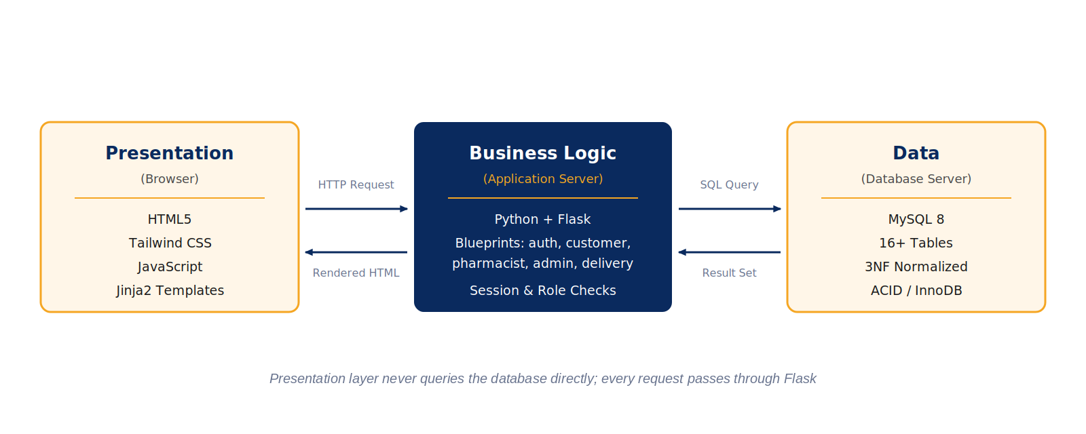
Fig 1: SehatHub 3-Tier Architecture

4. Database Design
The database was normalized to remove redundancy and enforce data integrity. An Entity–Relationship diagram was drawn first to map entities and cardinalities before writing any CREATE TABLE statements. The schema spans 16+ interconnected tables covering authentication, the medicine catalog, orders, and trust & safety.

◆ 4.1 Core Entities
Table | Purpose
users | Base account record; role field differentiates all four user types
customers / pharmacists / admins / delivery_managers | Role-specific profile data (1:1 with users)
medicines | Catalog: name, brand, category, price, stock, OTC/Prescription type
medicine_categories / brands | Lookup tables (1:N with medicines)
cart / cart_items | Active shopping cart per customer
orders / order_items | Placed orders and their line items
prescriptions | Uploaded prescription images with approval status
reviews | Customer ratings & comments per medicine

◆ 4.2 Entity–Relationship Diagram
The diagram below maps every entity, its attributes, and the cardinality of each relationship (1:1, 1:N) before physical implementation. This is the standard first step of database normalization.
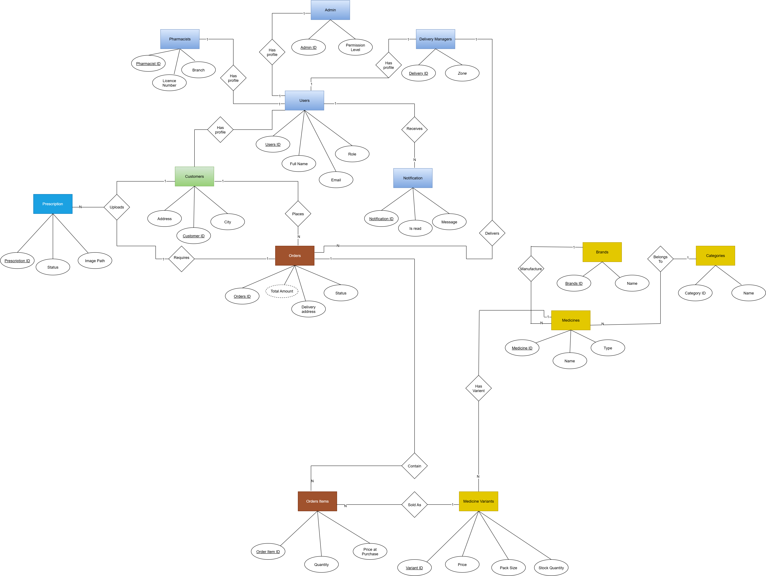
ER Diagram: Entities, Attributes & Cardinalities
Fig 2: SehatHub Entity-Relationship Diagram

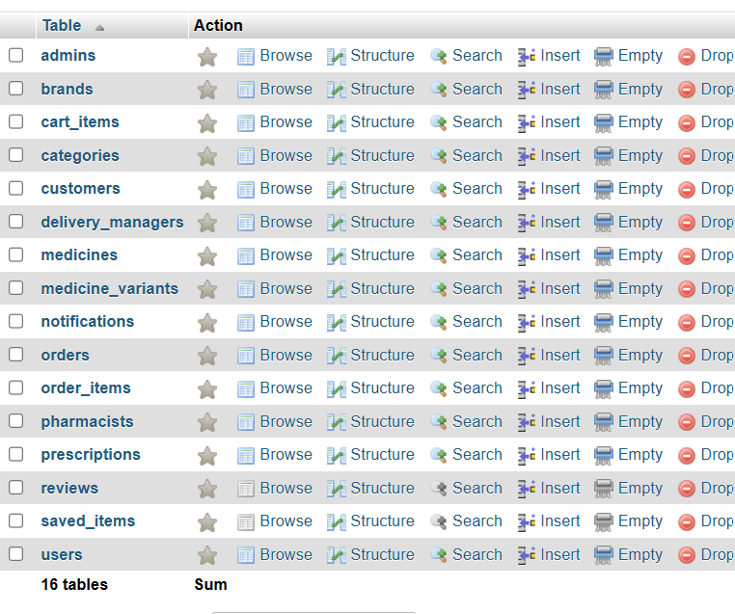
phpMyAdmin: Full Table List
Fig 3: SehatHub Database Schema in phpMyAdmin
Normalization & ACID Compliance
The schema is normalized to Third Normal Form (3NF): every non-key attribute depends only on its table's primary key, with role-specific and lookup data (categories, brands) split into their own tables to eliminate redundancy. MySQL's InnoDB engine guarantees Atomicity, Consistency, Isolation, and Durability (ACID) for every transaction, which matters most during order placement, where stock decrements and order-row inserts must succeed or fail together.

5. Key Features

◆ 5.1 Authentication & Account Management
- Role-aware signup for Customer, Pharmacist, Admin, or Delivery Manager, each with its own required fields
- Secure login with credential validation and role detection on every sign-in
- Passwords stored using Bcrypt hashing, never in plain text
- Forgot Password / Reset Password flow for account recovery
- Server-side session management, with the session cleared completely on logout
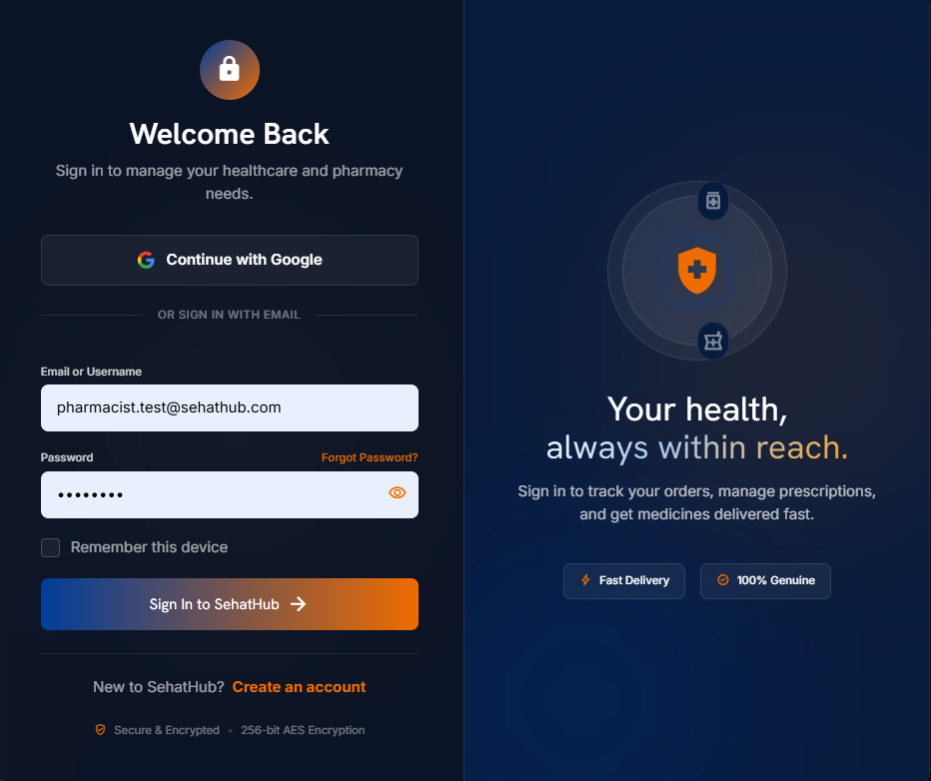
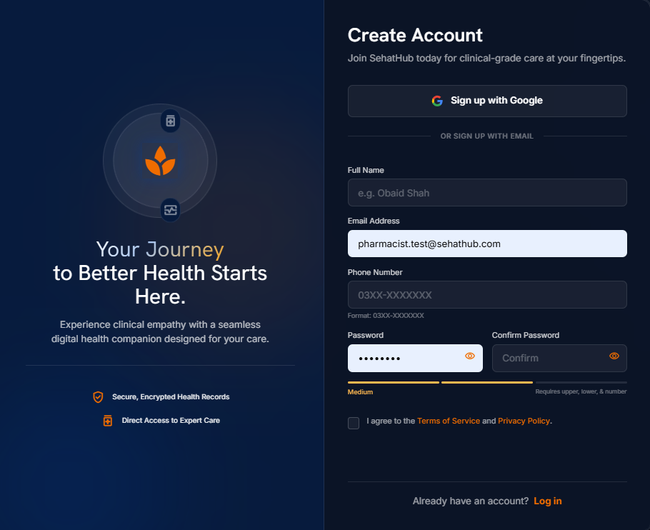
Login & Signup Pages
Fig 4: Login and Signup Screens

◆ 5.2 Customer Experience
- Medicine catalog with live search, category, brand, and price filters
- Cart, checkout, and Cash-on-Delivery order placement
- Prescription upload with pharmacist approval workflow
- Real-time order tracking timeline: Placed → Confirmed → Packed → Shipped → Delivered
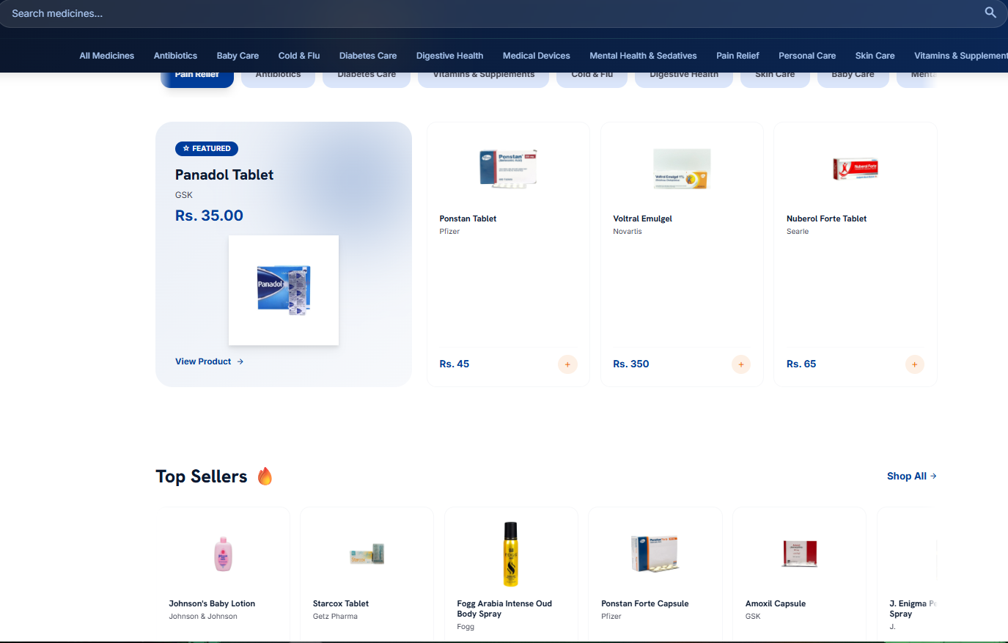
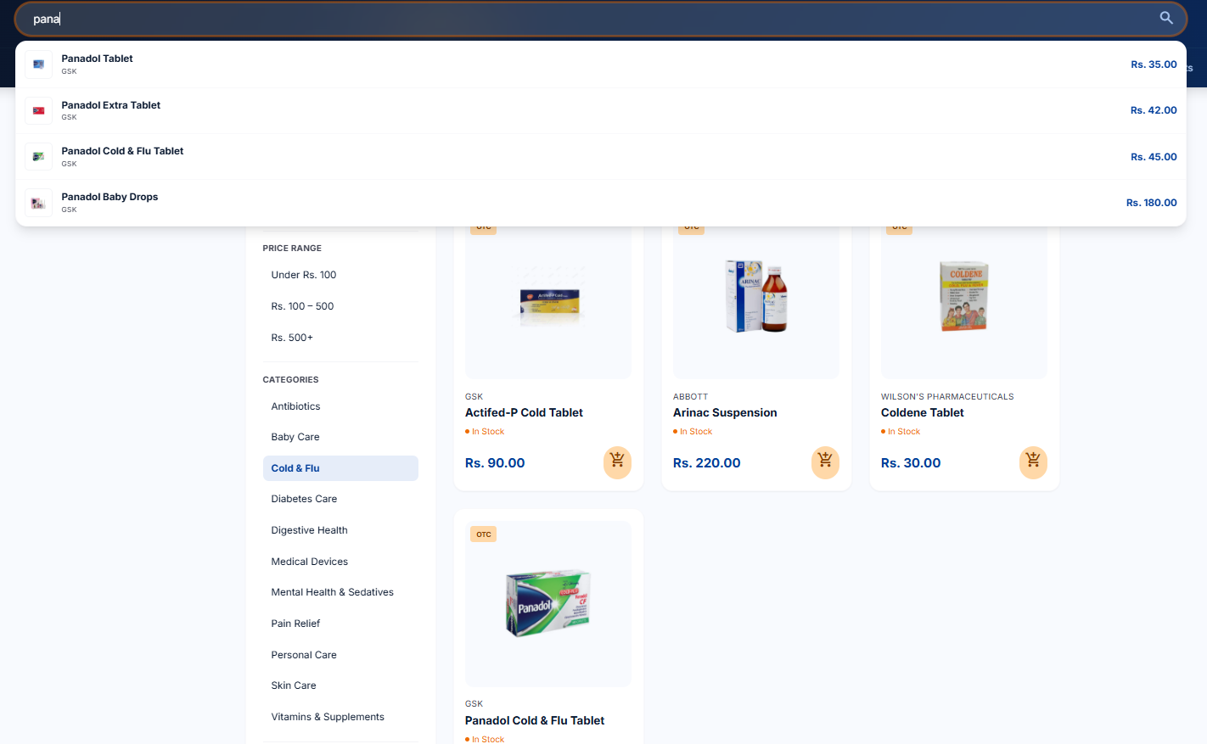
Homepage / Medicine Catalog
Fig 5: Customer-Facing Homepage

◆ 5.3 Pharmacist & Admin
- Stock management with low-stock and expiry alerts
- Prescription verification queue (approve / reject)
- Admin analytics dashboard covering revenue trends, top-selling medicines, and user management
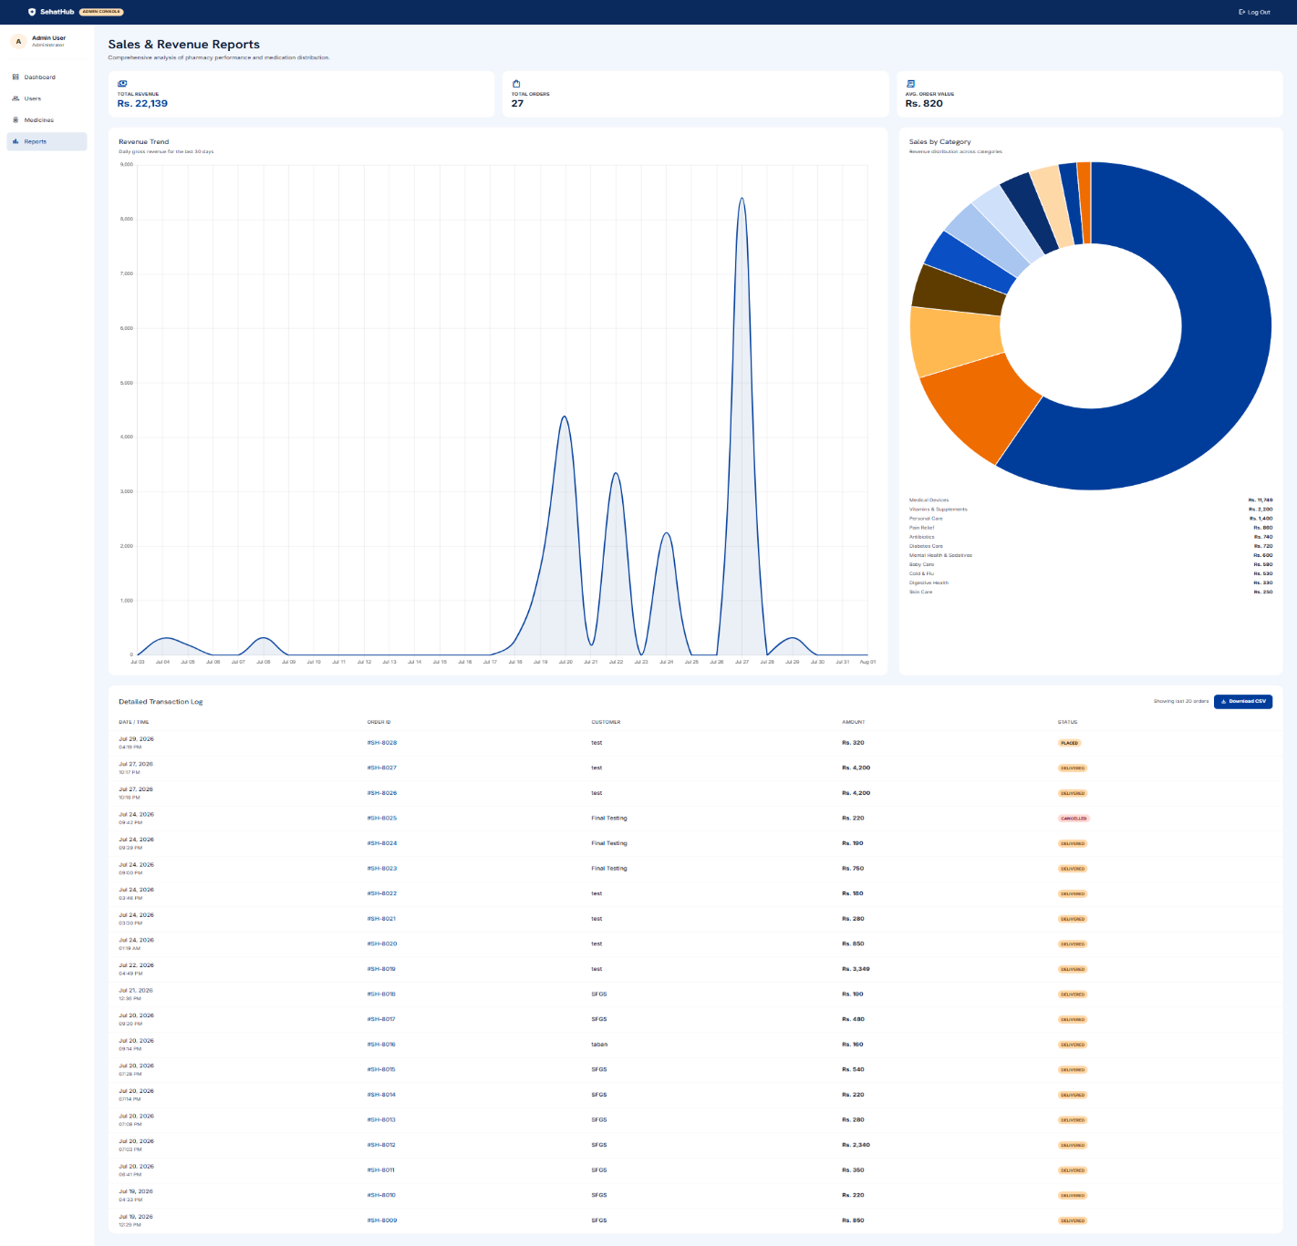
Admin Dashboard: Sales Analytics (Chart.js)
Fig 6: Admin Analytics Dashboard

◆ 5.4 Delivery Management
- Dedicated dashboard listing every order assigned to a delivery manager's zone
- One-tap status updates as an order moves to Out for Delivery and then Delivered
- Delivery zone assignment, feeding directly into the customer's order-tracking timeline

6. Security Implementation
SehatHub follows OWASP Top 10 guidance to defend against common web attack classes:
SQL Injection  Parameterized queries throughout (mysql-connector-python) |  | Cross-Site Scripting (XSS)  Jinja2 auto-escaping on all rendered templates
Cross-Site Request Forgery  CSRF tokens validated on every state-changing request |  | Password Theft  Bcrypt hashing; passwords never stored in plain text
Unauthorized Access  Role-based route decorators on every protected endpoint |  | Session Hijacking  Secure, HttpOnly, SameSite session cookies

Why this matters
By keeping the browser fully isolated from MySQL and routing every operation through Flask, a single, auditable layer enforces all security rules, instead of relying on the frontend to behave correctly.

7. Technology Stack
FRONTEND  HTML5, Tailwind CSS, JavaScript, Jinja2 templating |  | BACKEND  Python, Flask (modular Blueprints: auth, customer, pharmacist, admin, delivery)
DATABASE  MySQL (relational, ACID-compliant) |  | SECURITY  Bcrypt, custom CSRF & rate-limiting utilities, parameterized queries

8. Sample Database Queries

◆ 8.1 Fetching Complete Order Details (INNER JOIN)
Builds a customer's order receipt by joining orders, users, order items, and medicines:
SQL
SELECT o.order_id, u.full_name AS customer_name,
m.name AS medicine_name, oi.quantity, oi.price
FROM orders o
JOIN users u ON o.customer_id = u.user_id
JOIN order_items oi ON o.order_id = oi.order_id
JOIN medicines m ON oi.medicine_id = m.medicine_id
WHERE o.order_id = 1001;

◆ 8.2 Low-Stock Report (LEFT JOIN + GROUP BY)
Gives the pharmacist a per-category medicine count for the inventory dashboard:
SQL
SELECT c.name AS category_name,
COUNT(m.medicine_id) AS total_medicines
FROM medicine_categories c
LEFT JOIN medicines m ON c.category_id = m.category_id
GROUP BY c.category_id
ORDER BY total_medicines DESC;

◆ 8.3 Finding Unlinked Prescriptions (RIGHT JOIN)
Flags any uploaded prescription that is not yet tied to an active order, so a pharmacist can follow up:
SQL
SELECT p.prescription_id, p.status, o.order_id
FROM orders o
RIGHT JOIN prescriptions p ON o.order_id = p.order_id
WHERE o.order_id IS NULL;

◆ 8.4 Full Customer Engagement Report (FULL OUTER JOIN)
Lists every registered customer alongside every placed order, including customers who have not ordered yet, for an admin engagement audit. MySQL has no native FULL OUTER JOIN, so it is emulated with a UNION of LEFT and RIGHT JOIN:
SQL
SELECT u.user_id, u.full_name, o.order_id, o.status
FROM users u
LEFT JOIN orders o ON u.user_id = o.customer_id
WHERE u.role = 'Customer'
UNION
SELECT u.user_id, u.full_name, o.order_id, o.status
FROM users u
RIGHT JOIN orders o ON u.user_id = o.customer_id
WHERE u.role = 'Customer';

9. Conclusion & Future Scope

◆ 9.1 Conclusion
SehatHub demonstrates the practical application of DBMS concepts covered this semester, including normalization, foreign-key constraints, JOIN operations, and role-based access, on top of a real, working web application. The project takes a genuine problem (manual pharmacy operations) and solves it end-to-end, from schema design to a secure, multi-role Flask application.

◆ 9.2 Future Enhancements
- Online payment gateway integration, beyond Cash on Delivery
- OCR-based prescription reading to auto-extract dosage details
- Automated email/SMS stock alerts for pharmacists
- Refill reminders and medicine subscription plans

16+  Database Tables |  | 4  User Roles — Customer, Pharmacist, Admin, Delivery Manager
5  Core Modules — Auth, Customer, Pharmacist, Admin, Delivery |  | 3-Tier  Architecture — Presentation → Business Logic → Data

